FabClothing Cloud Migration Strategy
Technology Consulting Case Study
Author: Precious Mbah
Date: 28 August 2026
Objective: Evaluate the technical, financial and operational implications of migrating Fabclothing on-premise IT infrastructure to the cloud.
Company Overview
FabClothing is a fictional New York-based online clothing shop which I will be using as the case study for this project. The company serves about 100,000 customers and has approximately 500 employees.
The main website and supporting IT infrastructure are hosted by physical severs within an on-premise data centre. Due to the growth of the company, the existing infrastructure is becoming difficult to maintain and scale. Therefore, FabClothing is considering if migrating selected workloads to cloud platforms could improve operational efficiency and scalability.

Attribute | Assumption
Industry | Online clothing
Location | USA
Employees | 500
Customers | 100,000
Revenue | $50 million
Current infrastructure | Primarily on-premises
Proposed cloud provider | AWS
Note: All company information and financial figures in this case study are simulated assumptions created for the purpose of the project.

Current Technology Environment
Currently, Fabclothing operates its core IT infrastructure using physical servers located within an on-premise data centre. The environment supports the company's customer-facing website, application services, databases and file storage.

Tabular representation of current environment
Component | Current environment | Purpose
Application servers | 4 physical servers | Run business logic
Web servers | 4 physical servers | Host website
Database server | 2 physical servers | Stores customer information
Network | On-premise network | Connect infrastructure
Storage | 20 TB | Product images, backups and documents
IT team | 8 employees | Infrastructure and application support

Current Challenges
- Infrastructure maintenance – The IT team is responsible for replacing hardware, managing capacity and physical servers.
- Limited scalability – The physical infrastructure has a fixed capacity. This is a major problem because during peak sales period such as black Friday the company may require additional computing capacity, which may take time and creates additional capital expenditure which won’t be needed during regular sales periods
- Disaster recovery - Reliance on physical infrastructure creates additional requirements around backup, hardware failure and disaster recovery.
- Resource utilisation - Infrastructure needs to be sized to cope with peak demand. This can result in servers being underutilised during periods of lower demand.

Cloud Migration Drivers
There are several things that presents cloud migration as appealing to Fabclothing which are:
- Scalability: Ability to increase infrastructure capacity as demand grows
- Cost Structure: Reduce reliance on large upfront hardware purchases
- Availability: Improve resilience through appropriate cloud architecture
- Speed: Infrastructure working more quickly
- Managed services: Some administration being reduced
- Elasticity: ability to increase or decrease resources based on demand
However, cloud migration does not automatically guarantee lower costs. The financial case will therefore be evaluated using a three-year Total Cost of Ownership (TCO) model that considers both existing infrastructure and estimated cloud costs.

Project Objectives
The objective of this project is to evaluate whether Fabclothing should migrate its existing infrastructure to AWS and, if appropriate, develop a proposed migration strategy.
- Analyse the current infrastructure.
- Identify the main business and technology challenges.
- Design a proposed AWS architecture.
- Compare alternative migration approaches.
- Estimate three-year infrastructure costs.
- Identify migration and technology risks.
- Develop a phased migration roadmap.
- Create a management-level recommendation.

Current system architecture
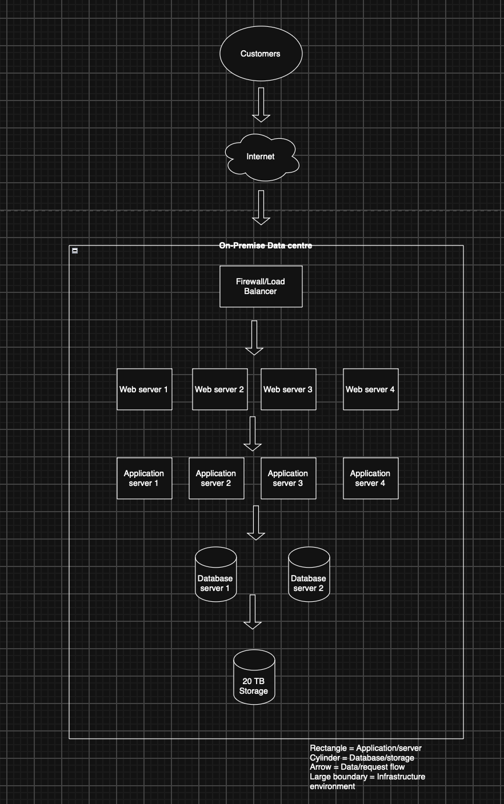

Proposed AWS architecture system

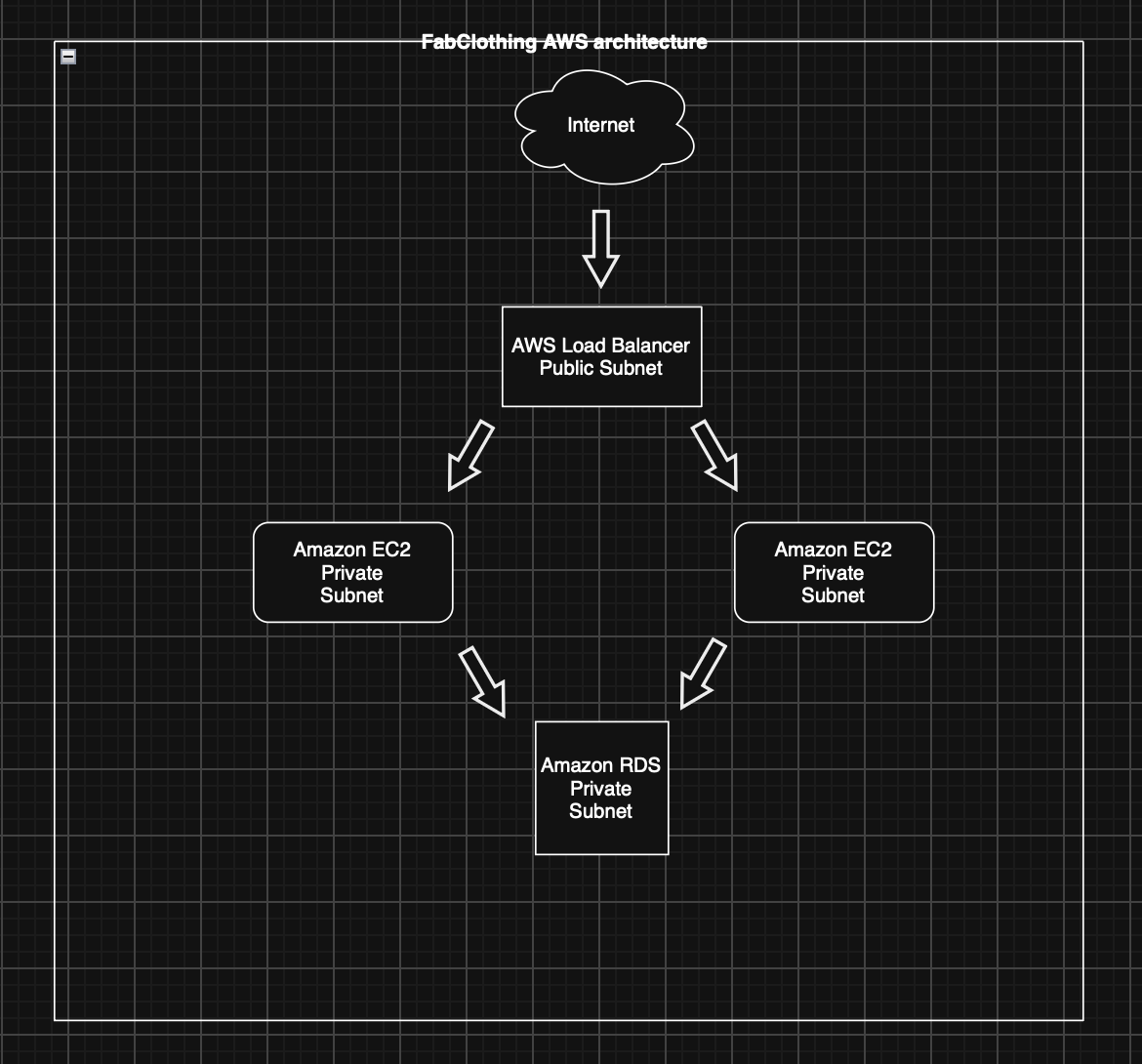

Benefits of AWS Architecture
AWS Service | Role | Why it is required
Load Balancer | Traffic distribution | Distribute customer request
EC2 | Application Compute | It runs applications workload
RDS | Relational database | Stores customer data
S3 | Object storage | Stores files/images
VPC | Private network | Isolate and control network
CloudWatch | Monitoring | It monitors application

Customer Request flow
- A customer accesses the FabClothing website through the internet.
- The request goes to the AWS load balancer.
- The load balancer distributes the request to the EC2 instance.
- The application processes the request.
- If customer or product data is required, the application communicates with Amazon RDS.
- Static files such as product images can be stored in Amazon S3.
- CloudWatch collects relevant monitoring information.

Cloud Migration Strategy
Proof of concept – This proof-of-concept environment was created to validate the feasibility of the prosed cloud migration. The aim was to gain practical experience setting up an application to the cloud. A Linux-based amazon EC2 instance was launched in an AWS network known as the VPC and it was configured with a security group which permits web traffic. An Apache web server was best fit to be configured to host a basic webpage for FabClothing and the deployment demonstrates the fundamental flow from a user's browser through the internet to an AWS-hosted application server.
Proof of concept objectives
- Deploy a virtual server using Amazon EC2.
- Configure basic AWS networking.
- Configure access controls using an EC2 Security Group.
- Connect to and administer a Linux cloud server.
- Install and configure a web server.
- Deploy a basic HTML webpage.
- Access the webpage through the internet.

Proof of concept Architecture
This architecture is made up of a single Amazon EC2 instance in an AWS VPC and this instance is assigned to a public address which allows HTTP request from the internet to reach the web server. An EC2 security/firewall is used to control network traffic.

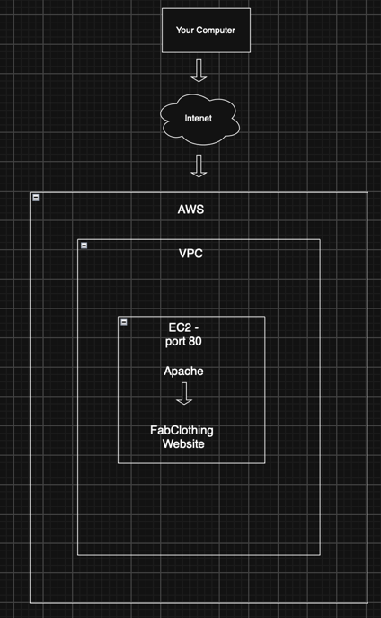
AWS Environment Table
Component | Implementation | Purpose
Cloud provider | Amazon Web Services (AWS) | They provide the cloud infrastructure
AWS Region | US East(N. Virginia) | Geographic location of the resource
Network | Amazon VPC | They provide the virtual network
Compute | Amazon EC2 | They provide the virtual server
Operating system | Amazon Linux 2023 | Acts as the OS for the server
Security | EC2 security group | Controls network traffic
Web server | Apache HTTP server | It serves the website
Application | HMTL webpage | Displays the deployed application

EC2 Deployment
An Amazon EC2 instance was launched to provide the compute environment for the proof of concept. Amazon Linux 2023 was selected as the operating system. A small instance configuration was used because the application was only a demonstration website and did not require significant computing resources. A key pair was configured to provide secure access to the instance. The EC2 instance was assigned a public IPv4 address to allow the hosted webpage to be accessed through a web browser.
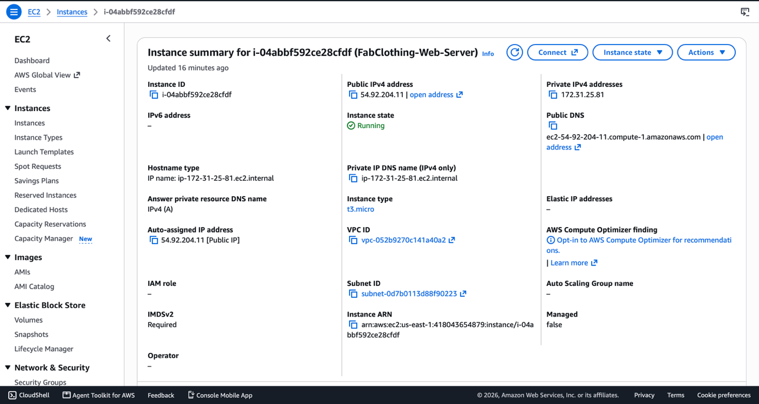

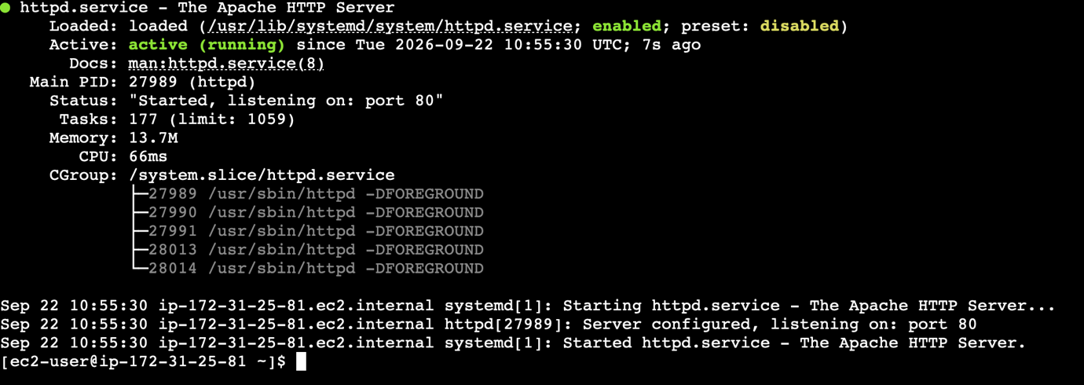
Web Server Configuration - Apache HTTP Server was installed on the Amazon Linux EC2 instance. Apache was configured to serve HTML files from the /var/www/html/ directory.
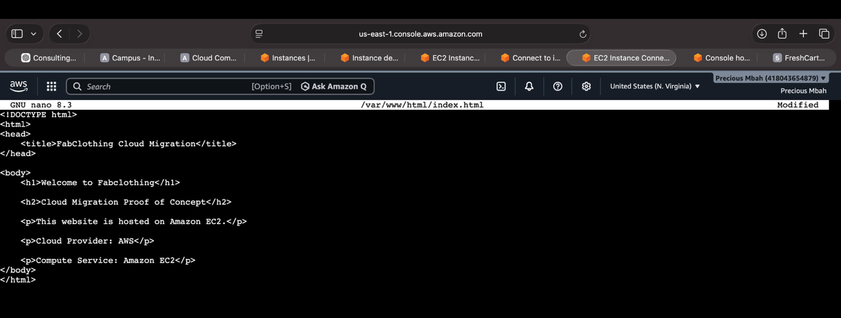
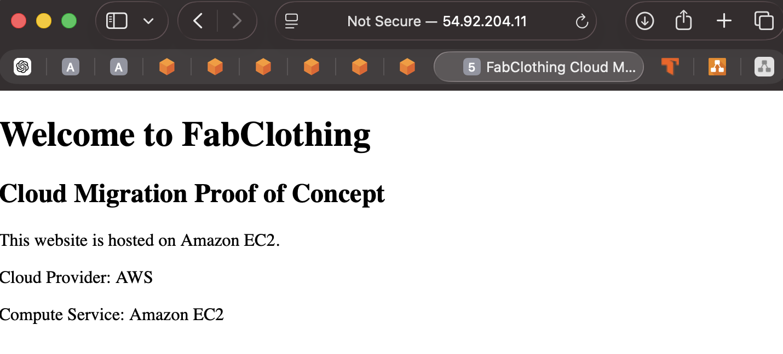

Customer request Flow
- The user enters the website's public IP address into their browser.
- The request travels through the internet to the AWS public IP address.
- The EC2 Security Group evaluates the incoming traffic.
- HTTP traffic on port 80 is permitted.
- The request reaches the EC2 instance.
- Apache receives the HTTP request.
- Apache retrieves the index.html webpage.
- The HTML is returned to the user's browser.

Proof of concept limitations
Although the proof of concept has some great strengths, it also come with a few limitations which must be taken into considerations such as: It only consist of a single EC2 instance which would limit the availability, it has no load balancer therefore it might be quite difficult to distribute traffic, it also has no managed database which means there would be an issue with storing customer data. But all of these issues can be resolved by e.g. using amazon RDS, implementing an elastic load balancer and using multiple instance rather than single instance.

Proof of concept Conclusion
The AWS proof of concept successfully demonstrated the deployment of a simple web application using Amazon EC2. The exercise provided practical experience with cloud compute, networking, security groups, Linux server administration and web hosting.
The implementation also highlighted the difference between a basic proof of concept and a production cloud architecture. While the POC used a single EC2 instance, the proposed FabClothing production architecture would use additional AWS services to address availability, scalability, database management, storage, monitoring and security requirements.

Financial Analysis

Financial Modelling Approach
I created a three-year totoal cost of ownership model to compare the on-premise infrastructure with the proposed AWS environment. This financial model takes into account maintenance staffing, storage etc

Financial Assumptions
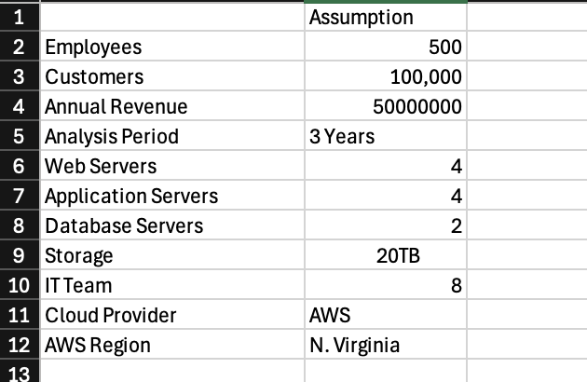

On-Premise Cost Model
The simulated figures in the table below display the current cost of the on-premise system which is used by Fabclothing.

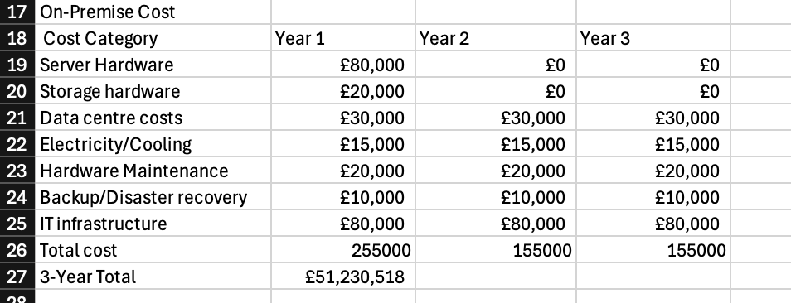

Proposed AWS Cost Model
The simulated figures in the table below displays the cloud environment which could be used by FabClothing if they find it fitting for them.

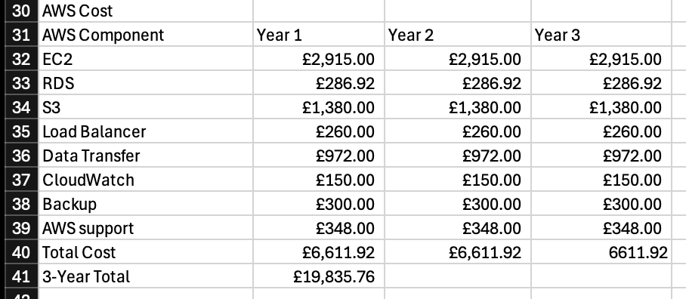

Migration Cost
The simulated figures in the table below displays how much it would cost Fabclothing to fully migrate all their current on-premise systems onto the cloud.

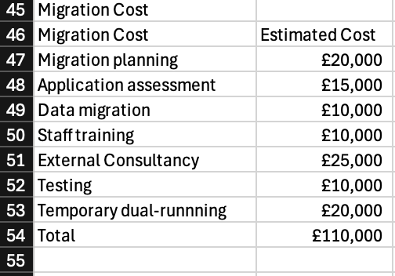
Total cost of comparison
The charts and table below displays the difference between the cost of both environments and the cost of the move from the on premise environment unto the cloud. It clearly shows that the on-premise system is very expensive for FabClothing which alongside its other limitations such as the lack of scalability and difficulty to maintain, this suggest that a migration to the cloud might be immensely beneficial to FabClothing in the long run.

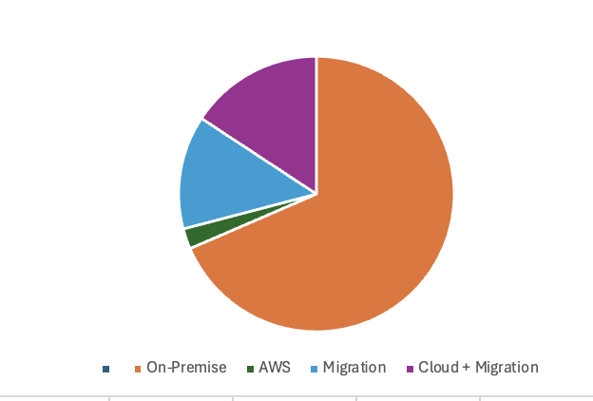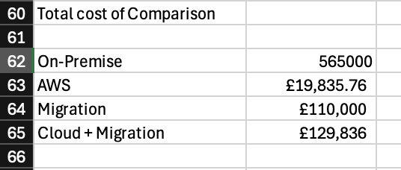

Financial considerations
The financial analysis compares the expected costs of maintaining the existing on-premise infrastructure with the costs associated with operating the proposed AWS environment.
The analysis considers both direct infrastructure costs and wider operational factors, such as data-centre hardware, maintenance, computing resources, database services, monitoring, and data transfer.
The AWS model uses usage-based pricing, meaning that costs will vary depending on the amount of computing, storage, network traffic and other services consumed. The figures used in the model are therefore estimates based on defined workload assumptions rather than fixed costs.
Capital vs operating expenditure – The on-premises environment needs things such-as physical servers and storage equipment (capital expenditure) which can be very costly. While the cloud model allows FabClothing to pay for resources depending on the usage (operating expenditure) and this can be more affordable for Fabclothing

Overall, the financial impact of cloud migration depends on both the underlying workload and how effectively the AWS environment is managed. On-premise infrastructure involves significant investment in physical hardware and ongoing operational costs, while AWS shifts expenditure towards usage-based services. Migration also introduces initial transition costs that should be considered separately from ongoing cloud expenditure. The financial analysis therefore focuses on total cost of ownership, resource utilisation and cost management rather than assuming that cloud adoption will automatically result in lower costs.

Migration Risk and Strategy
Chosen Migration Approach – Phased Migration. This is the chosen migration approach because it reduces risk while allowing for workloads to be tested progressively. So web and application workloads could be rehosted first onto Amazon EC2 and the database environment could be migrated to Amazon RDS.

Migration roadmap
- Access: Here the applications and servers are identified
- Design: Then the AWS architecture needs to be designed and the security processes needs to be defined
- Build: The required services needs to be deployed and AWS environment needs to be configured
- Pilot: Here, small workloads can be migrated and tested for performance and functionality
- Migrate: Then workload can be migrated in phases and systems can be validated
- Optimise: Then performance will be monitored and optimised if needed

Key Migration Risk
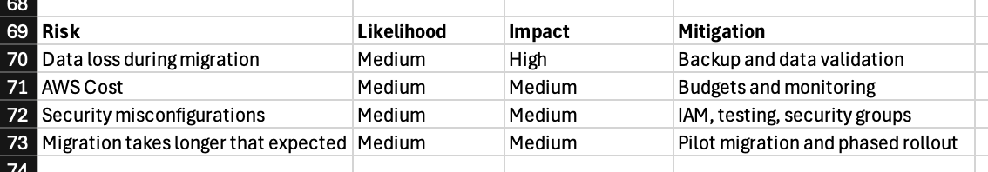

Rollback strategy
Before switching completely to the AWS environment, the migrated workload should be tested and validated. If critical problems are identified, the organisation should be able to return to the existing environment while the issue is investigated.

